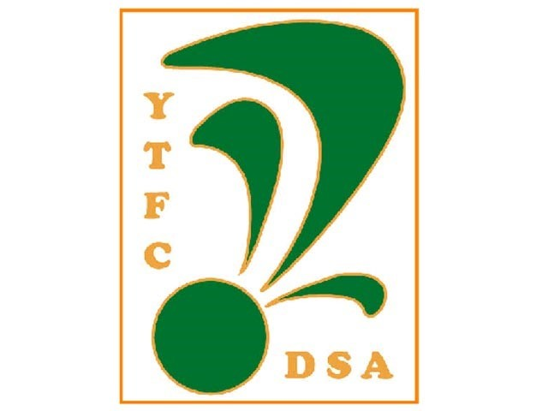Mike Rowsell and Simon Woodland from the DSA attended our 1st game back in the national league on Saturday 3rd August away to Barnet. Here we give our impressions on what visiting the Hive is like for the disabled fan.
We made use of the Green and Whites coach and travelled up to Barnet’s Hive ground. Sods law there was a accident on the A303 meaning a lengthy detour which resulted in us not arriving there until 2.45pm.The coach parked right outside the ground which was a bonus we thought only to be met by 500 plus Yeovil fans trying to buy tickets as it was a pay on day. I said to Mike I am so glad I rang them in week to buy our tickets and we only had to pick them up how wrong was I. Being in a wheelchair meant you are not able to push your way through the ques to get to the correct window, the collection window being empty. luckily a kind police lady saw us struggling and helped us to the front of the que and the empty window. Once inside we were told we could sit anywhere we liked on the front row so there was plenty of choice and your assistant who goes with you free of charge could sit next to you. But be warned if you are going on a rainy day you are open to the elements so some wet weather gear would be needed There are two disabled toilets available which was handy but if like me you are in a wheelchair there is an annoying drain/ridge along the doorway which took me 3 attempts to get over. Another annoying aspect was the stewards that were standing along the edge of the stand sometimes blocking your view.
I don’t think Barnet were expecting 500+ fans from tiny little Yeovil to attend and were caught off guard.
Our verdict: Would we go again, YES but next time have the tickets posted beforehand.
