Ebbsfleet v Yeovil Town 13 August 2019 Report

Last Tuesday night, DSA Committee members Mike Rowsell and Simon Woodland decided to use the excellent away travel provided by the Green and Whites supporters club to go and watch Yeovil Town play Ebbsfleet. Leaving Hush Park at 1:45 in the afternoon. We had an excellent journey up there. Stopping off at Fleet services for half an hour and still arriving at the ground in plenty of time.

Arriving at the ground it looks very nice from the outside. However, when the coach arrived, they were unable to park close due to cones being in the way and fussy stewards telling the driver she would have to drive off and park away from the ground. So, one of the drivers explained that they had two disabled people on board, and she would need to park closer to the ground. After talking to the Steward for some time. One of the drivers got out of the coach to move the cones so we could park there. To get into the ground you must go through the car park where we were warned by the stewards to go careful on our scooters as there were some big potholes along the way. I recommend being very careful as there are a lot of potholes. Most of them are very small however there are some big ones that if somebody was to run over or an ambulant person was to accidentally walk on, they would end up falling or tripping.

We arrived about 6 pm so understandably were told we could not go into the ground yet. This is standard at every ground so someone very kindly got our tickets for us. Some Yeovil supporters asked if we could go into their clubhouse and were told no, so we were taken to a concrete compound behind the away supporter’s section. Once inside this compound we were not allowed to leave it but there is a burger van there and in terms of alcoholic drinks they had none. It was only after a lot of moaning that one of the stewards drove to a local supermarket to buy some. Upon his return they had lukewarm cans of Fosters which they began to sell for £4 a can. Their excuse being that they weren’t expecting any Yeovil fans.

I have to say, as always, the Yeovil fans made the best of it and started singing and enjoying themselves. As you come into the compound there is a sign that signifies the accessible toilet. Unfortunately, this is misleading as I found out when I went in there it is just a standard toilet. I managed in the normal toilet however I wouldn’t recommend trying this if you are unable to weight bear. Once inside the ground Simon asked a steward about accessible toilets and was pointed in the direction of a small white building near the home end. Luckily this was a disabled toilet.

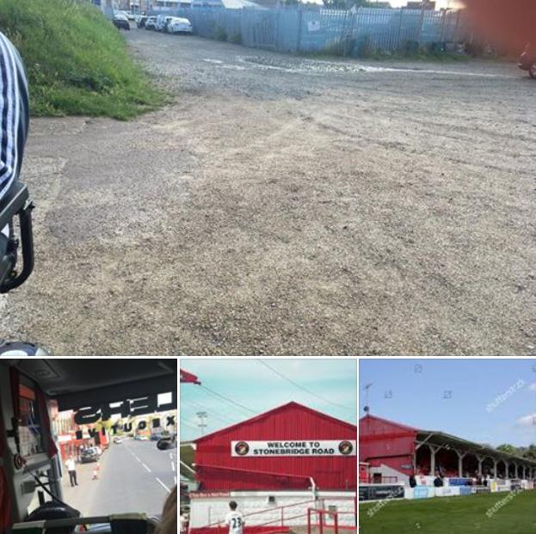

Despite the problems in the compound from a wheelchair user’s perspective, once you get into the ground you have an excellent view which is completely unobstructed and the fans are sat behind you. One thing that both Simon and I really liked was the fact that we could sit with our fellow Yeovil fans behind us which enabled us to feel part of the atmosphere. There is a small wall behind and in front of you and there is a seat for your assistant to sit with you should that be required. It is great that you are so close to the action the only thing is obviously you could get hit by the ball. At Ebbsfleet you are covered to a certain extent however I would recommend if it was raining you bring a coat.

Be extremely careful when leaving the ground if you go to a night game or a game during the winter. As it was dark when we left so coming out through the car park, we had to be very careful about the potholes, there is lighting, however it is minimal. The coach was not allowed to park right next to a curb when picking us up, so I had to have help lifting my scooter down the curb and a hand to board the coach. I would like to thank the people that helped me especially Paul Hadlow from the Green and Whites and Steve the coach driver from Ridlers.

I think Ebbsfleet do their best with what they’ve got whilst the compound isn’t great, and I believe the organisation for the coaches perhaps needs work. Once you’re in the ground they do their best to give you a great experience by being as helpful as they can. I think that’s all anybody can ask at times.

I would recommend going to Ebbsfleet FC again and in terms of the actual stadium, what I would say, however for disabled fans, is maybe do some research before you go and find a local pub as if it had been raining, we would’ve got soaked because the compound is not covered. On behalf of Simon and myself I would like to thank the drivers at Ridlers coaches who took us to Ebbsfleet for their excellent help and would also like to thank Paul Hadlow for the excellent work he does.

Report written by Mike Rowsell

